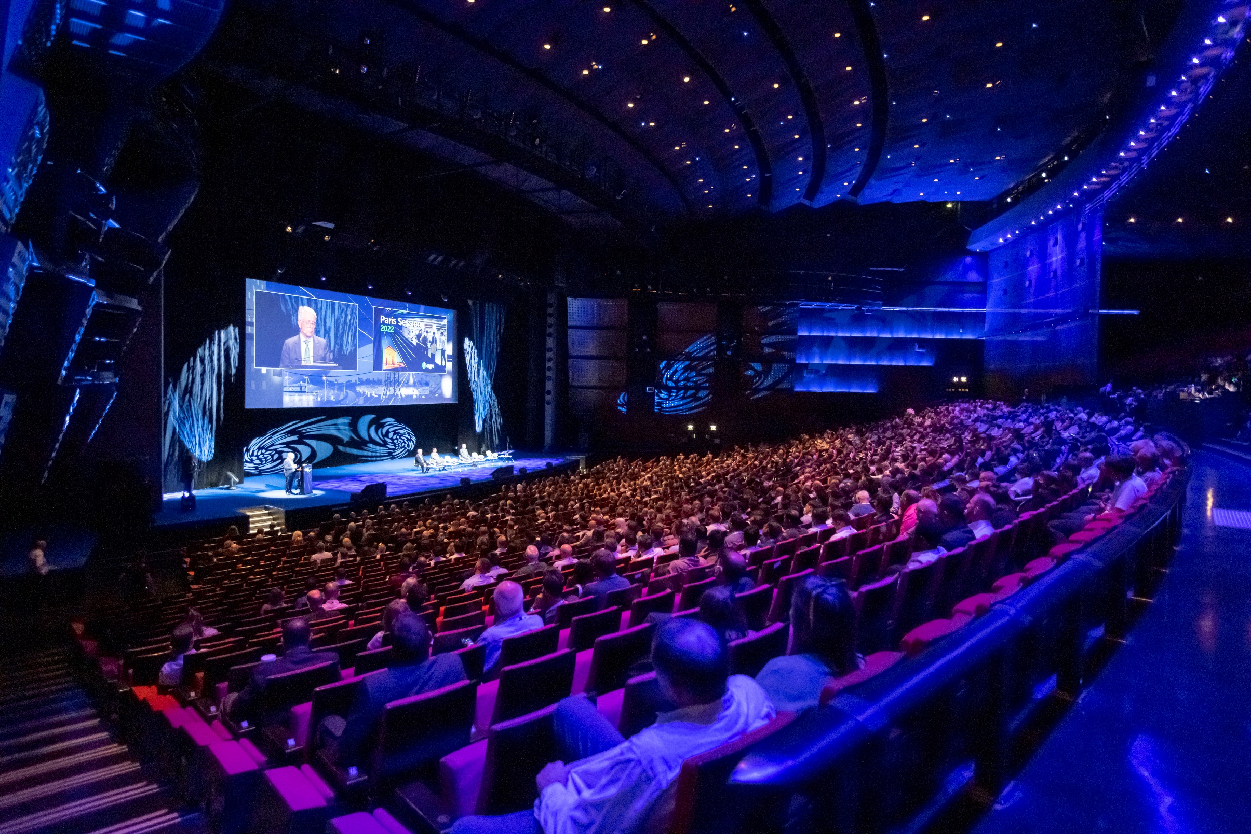

PARIS

SESSION

2024

SYNOPSES TEMPLATE

Please read carefully. These instructions and the attached template give you guidelines to prepare your synopsis.

Please follow strictly these instructions and provide us with the necessary information we need to consider your Paper Proposal.

Study Committee and Preferential Subject addressed are essential to direct your synopsis to the right person for reviewing.

Your email address is highly needed to keep you informed about the selection results.

Format must be A4 size with Margin: Left 1.27 cm, Right 1.27 cm, Bottom 1.27 cm. Study Committee, Preferential Subject and synopsis title must be with: Font Name Helvetica or Arial Bold size 12. Authorship must be with Times New Roman bold size 12 and center-aligned. Authors’ family name should be in Upper Case.

Text must be in one Column after Authors Name, Font Times New Roman size 12 and Line Spacing 1.15. A Length of 500 words minimum to two pages maximum is a good option to facilitate reviewing and selection.

About four Keywords in alphabetical order, separated by commas may serve as an introduction.

Tables or figures should be limited in number.

Thank you for your attention!